INTERNAL MEMO
DATE: 22 May 2026
TO: Director General
THRO’: Director, research and product development
FROM: Patrick Waweru Mwaura, Data Science and Analytics Section
SUBJECT: NOMINATION FOR INCLUSION IN PPRA TRAINING ON PROCUREMENT AUDIT AND COMPLIANCE
Following your guidance regarding the PPRA training programme for heads of departments and selected staff, I submit my nomination for inclusion in the said training.
The data science and analytics section supports institutional performance monitoring and development of data systems that enhance accountability and compliance across institutional processes, including procurement-related functions.
Participation in this training will strengthen the section’s capacity in procurement audit support, compliance monitoring, and alignment of institutional data systems with public procurement regulatory requirements.
I therefore request approval for my inclusion in the training programme and facilitation of the necessary administrative processing.

Respectfully submitted,
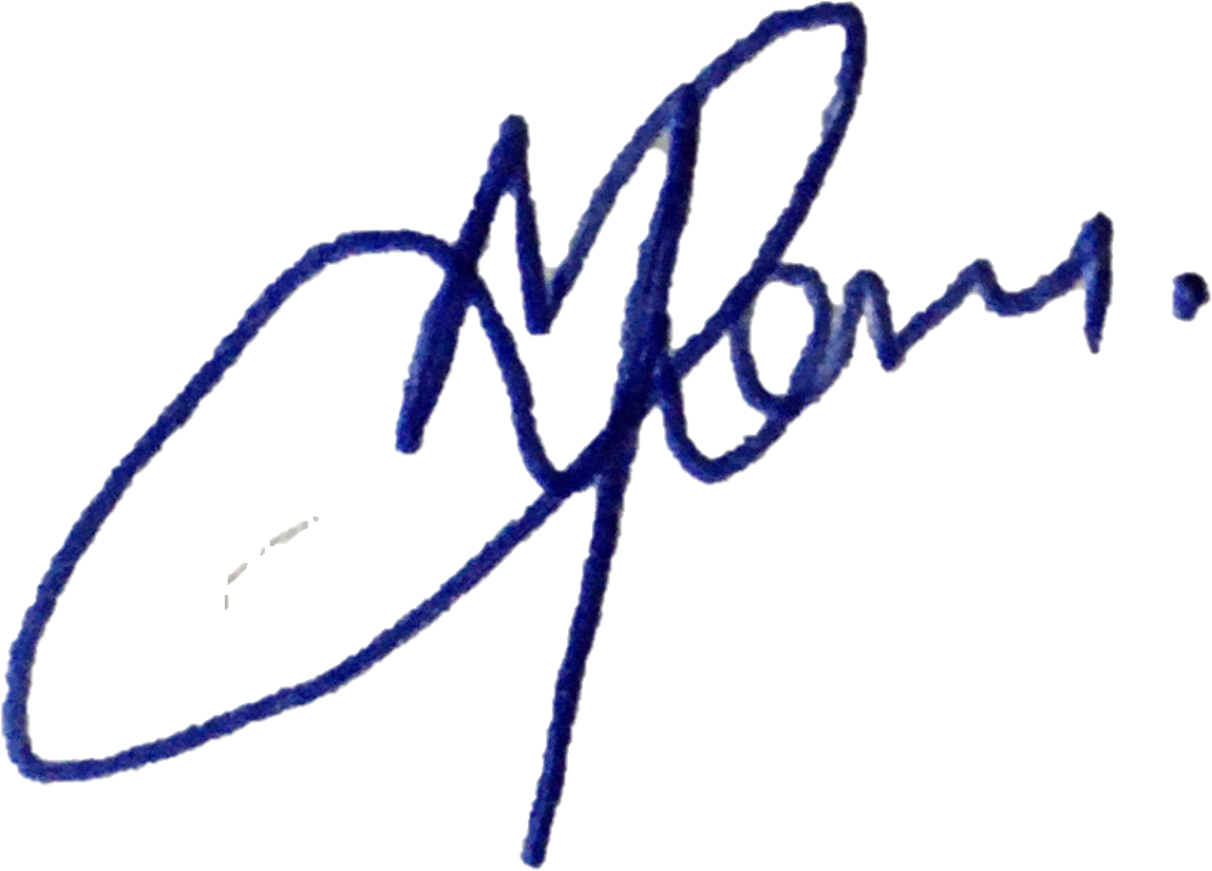
Patrick Waweru Mwaura
Data Science and Analytics

